 Connecting to LLU-EAP

Windows 7

- Right click the wireless icon in the taskbar.



- Click ‘LLU-EAP’

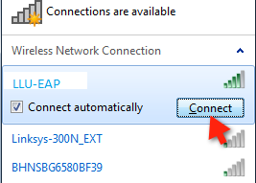

- Enter user name and password

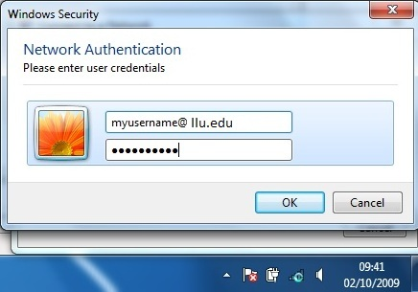

- Click ‘Connect’ again if you get a Windows Security Alert window with ‘Terminate’ and ‘Connect’ buttons

Mac OS

- Go to Airport settings. Let list refresh. Select LLU_EAP

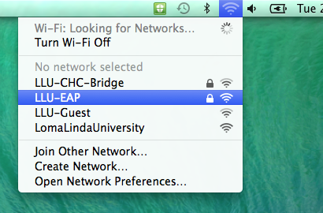

- Leave 802.1x to automatic

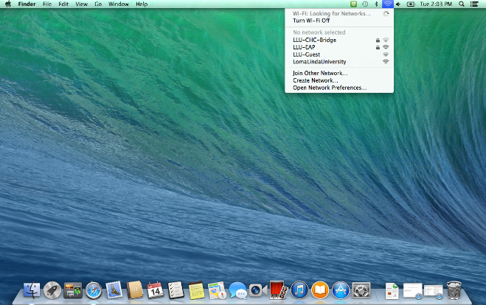

- Enter username and password

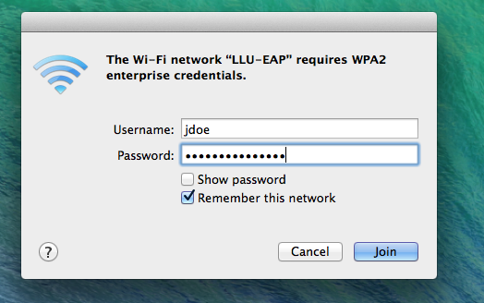

- Click continue to accept the certificate.

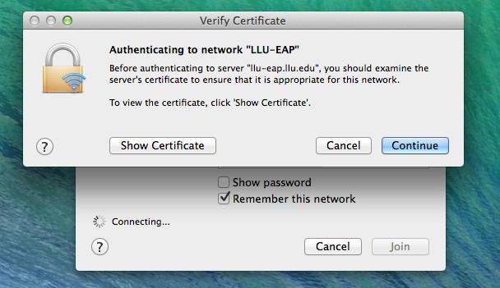

- On certificate invalid screen enter credentials used to log into the mac to accept the certificate.

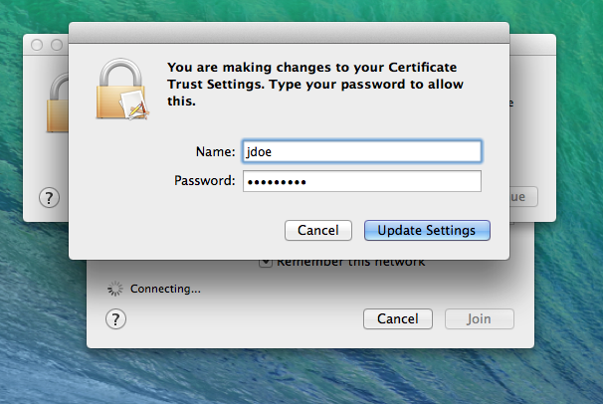

iPhone & iPad

- Go to Settings >Wi-Fi and select LLU-EAP: :

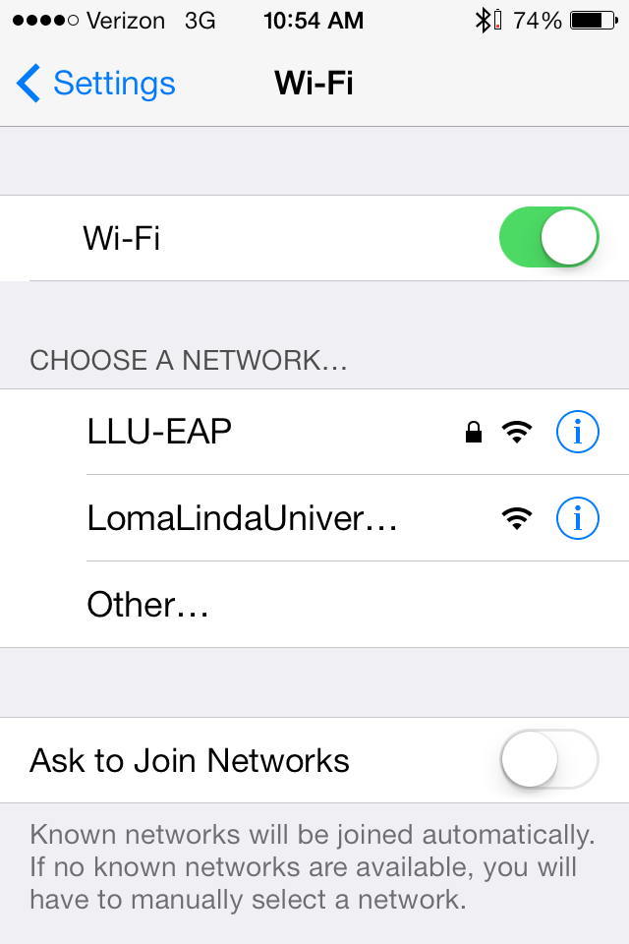

- On the login screen enter your user name and password

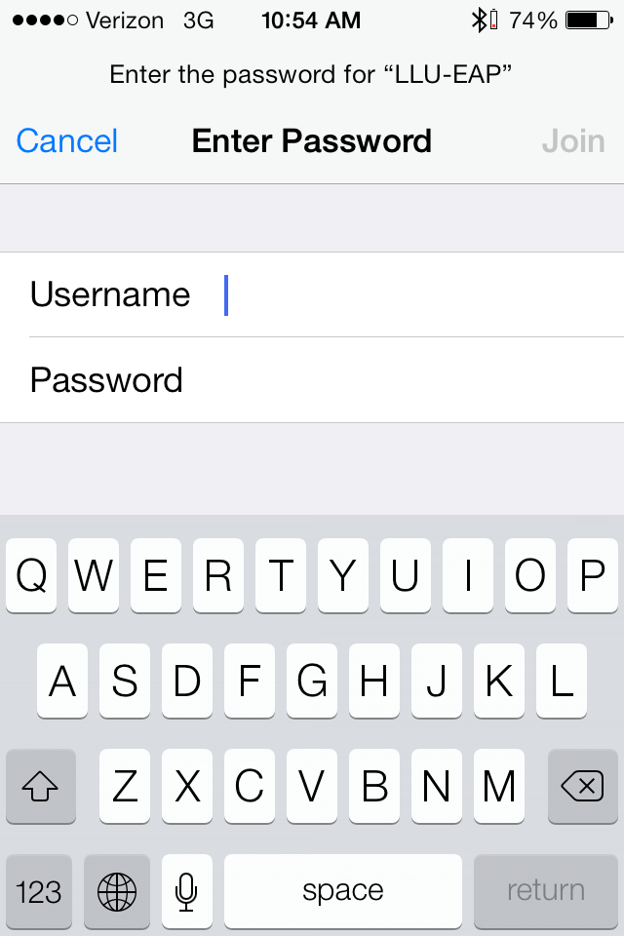

- Accept the certificate on the certificate invalid screen:
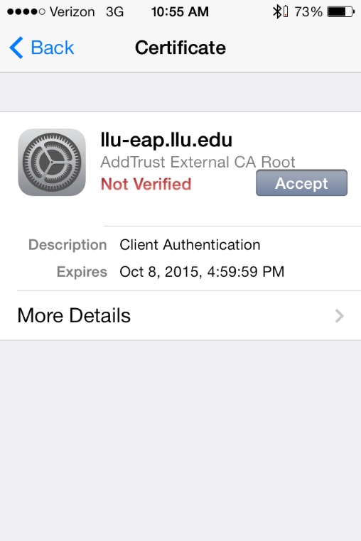

- You should see the following screen with the check mark next to LLU-EAP:

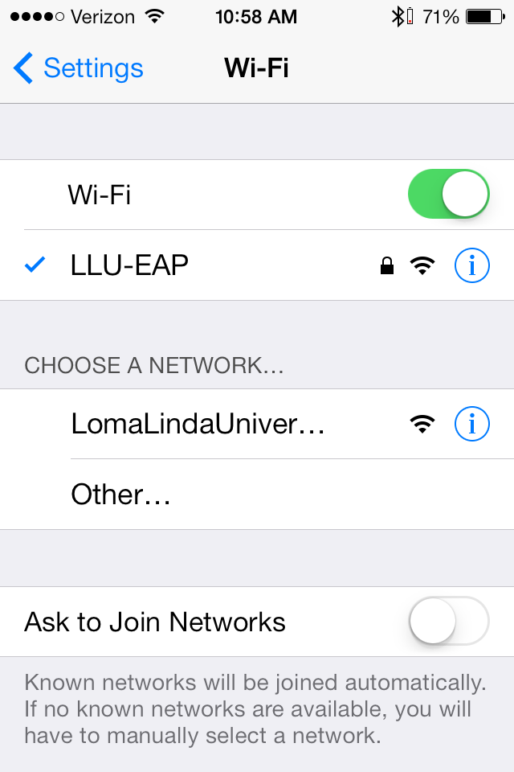
Android
- Go to Settings
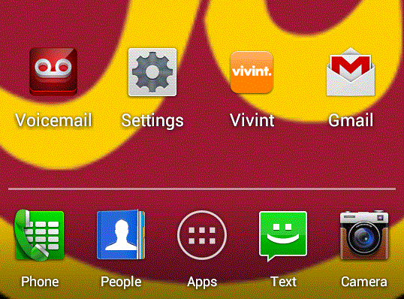

- Wi-fi

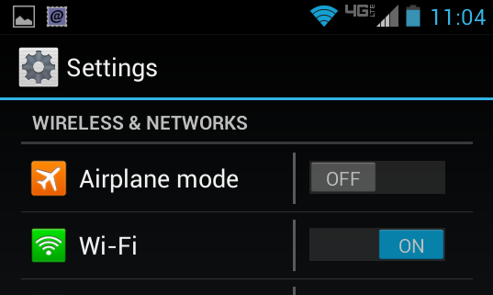

- Select LLU-EAP

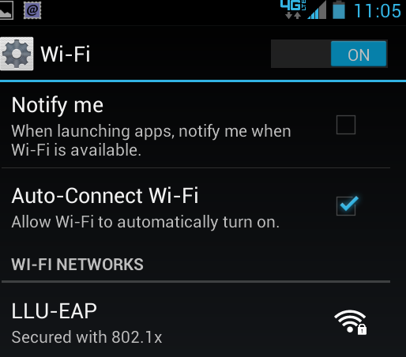

- Verify that CA certificate is (unspecified), User certificate is (unspecified)
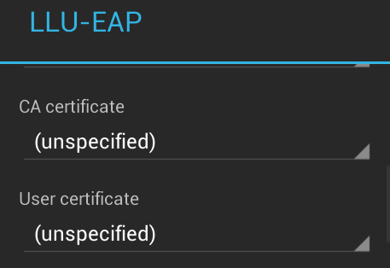

- Enter user name and password
(Identity and Password)

